WORKFLOW 1: ORDER PROCESSING
Event: OrderPlaced Triggered by: Customer via portal/phone Data: orderId, customerId, products[], quantities[], deliveryAddress, paymentMethod, timestamp Subsequent Events: AvailabilityChecked, OrderRejected
Event: AvailabilityChecked Triggered by: System automatically Data: orderId, products[], availabilityStatus[], insufficientStock[] Subsequent Events: OrderValidated, OrderRejected
Event: OrderValidated Triggered by: Sales operator Data: orderId, operatorId, finalTotal, timestamp Subsequent Events: StockReserved, InvoiceGenerated
Event: OrderRejected Triggered by: System/Operator Data: orderId, reason, timestamp Subsequent Events: None

WORKFLOW 2: INVOICE GENERATION
Event: StockReserved Triggered by: System automatically Data: orderId, products[], quantities[], warehouseId, timestamp Subsequent Events: InvoiceGenerated
Event: InvoiceGenerated Triggered by: System automatically Data: invoiceId, orderId, customerId, totalAmount, productDetails[], timestamp Subsequent Events: InvoiceSent
Event: InvoiceSent Triggered by: System automatically Data: invoiceId, orderId, customerEmail, sendMethod, timestamp Subsequent Events: OrderPrepared
Event: ReservationFailed Triggered by: System Data: orderId, reason, timestamp Subsequent Events: OrderRejected
Event: GenerationFailed Triggered by: System Data: orderId, reason, timestamp Subsequent Events: None

WORKFLOW 3: ORDER SHIPPING
Event: OrderPrepared Triggered by: Logistics operator Data: orderId, packageId, weight, dimensions, timestamp Subsequent Events: OrderHandedOver
Event: OrderHandedOver Triggered by: Logistics operator Data: packageId, orderId, courierId, awb, timestamp Subsequent Events: OrderDelivered, DeliveryFailed
Event: OrderDelivered Triggered by: Courier Data: packageId, orderId, timestamp, signature, confirmationPhoto Subsequent Events: None
Event: PreparationFailed Triggered by: System/Operator Data: orderId, reason, timestamp Subsequent Events: None
Event: DeliveryFailed Triggered by: Courier Data: packageId, reason, attemptNumber, timestamp Subsequent Events: OrderHandedOver (retry), OrderReturned
BOUNDED CONTEXTS pentru ORDER PROCESSING

Context 1: Order Management
Responsabilități:
- Primirea și validarea comenzilor de la clienți
- Gestionarea ciclului de viață al comenzii (placed → validated → rejected)
- Coordonarea cu alte contexte pentru verificări și procesări ulterioare
Evenimente care aparțin contextului:
- OrderPlaced
- OrderValidated
- OrderRejected
Comunicare cu alte contexte:
Evenimente publicate (shared events):
- OrderPlaced → trimis către Inventory Context pentru verificare disponibilitate
- OrderValidated → trimis către Invoice Context și Inventory Context pentru rezervare stoc
- OrderRejected → notificare către Notification Context (dacă există)
Comenzi primite de la alte contexte:
- ValidateOrder (command din sistem sau de la Sales Operator)
Evenimente consumate din alte contexte:
- AvailabilityChecked (din Inventory Context)
- StockInsufficient (din Inventory Context)

Context 2: Inventory Management
Responsabilități:
- Verificarea disponibilității produselor în stoc
- Gestionarea nivelurilor de stoc
- Raportarea indisponibilităților
Evenimente care aparțin contextului:
- AvailabilityChecked
Comunicare cu alte contexte:
Evenimente publicate (shared events):
- AvailabilityChecked → trimis către Order Management Context
Evenimente consumate din alte contexte:
- OrderPlaced (din Order Management Context) → trigger pentru verificare
Comenzi primite:
- CheckAvailability (command declanșat de OrderPlaced event)
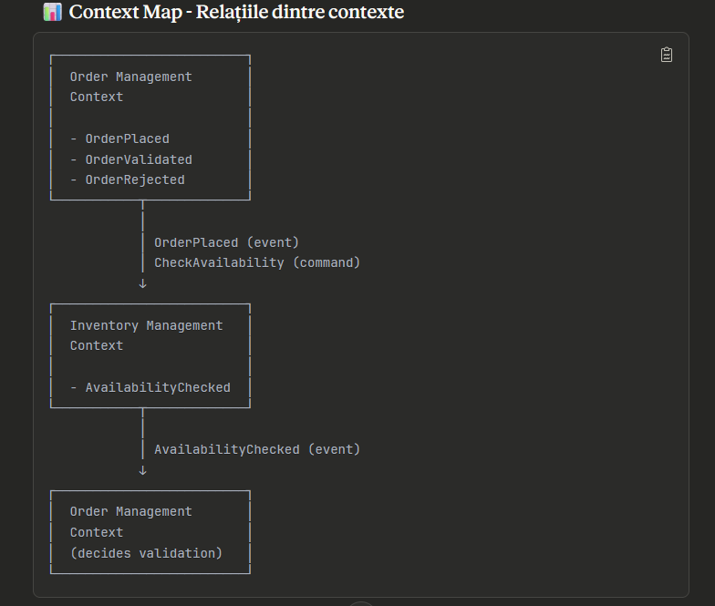

Flow complet prin contexte:
Step 1: Customer → PlaceOrder command Step 2: Order Management → OrderPlaced event Step 3: Order Management → CheckAvailability command → Inventory Management Step 4: Inventory Management → AvailabilityChecked event → Order Management Step 5: Sales Operator → ValidateOrder command → Order Management Step 6: Order Management → OrderValidated event OR OrderRejected event

Integrare cu celelalte workflow-uri (Invoice & Shipping):
Downstream events (trimise către alte workflow-uri):
- OrderValidated → Invoice Generation Workflow (trigger pentru StockReserved)
- OrderValidated → eventual Shipping Workflow (după ce factura e generată)
Note:
- OrderRejected oprește fluxul - nu se propagă către Invoice sau Shipping
- AvailabilityChecked rămâne intern în ORDER PROCESSING - nu iese din acest workflow

BOUNDED CONTEXTS pentru INVOICE GENERATION

Context 1: Inventory Management
Responsabilități:
- Rezervarea stocului pentru comenzile validate
- Gestionarea nivelurilor de stoc rezervat vs disponibil
- Eliberarea stocului în caz de eșec
Evenimente care aparțin contextului:
- StockReserved
- ReservationFailed
Comunicare cu alte contexte:
Evenimente publicate (shared events):
- StockReserved → trimis către Invoice Context
- ReservationFailed → trimis către Order Management Context (din ORDER PROCESSING workflow)
Evenimente consumate din alte contexte:
- OrderValidated (din Order Management Context - ORDER PROCESSING workflow)
Comenzi primite:
- ReserveStock (command declanșat de OrderValidated event)

Context 2: Invoice Management
Responsabilități:
- Generarea documentelor de factură
- Calcularea totalurilor, taxelor și reducerilor
- Gestionarea stării facturilor (generated → sent)
Evenimente care aparțin contextului:
- InvoiceGenerated
- GenerationFailed
Comunicare cu alte contexte:
Evenimente publicate (shared events):
- InvoiceGenerated → trimis către Notification Context
- GenerationFailed → trimis către Order Management Context
Evenimente consumate din alte contexte:
- StockReserved (din Inventory Management Context)
Comenzi primite:
- GenerateInvoice (command declanșat de StockReserved event)

Context 3: Notification Management
Responsabilități:
- Trimiterea facturilor către clienți
- Gestionarea canalelor de comunicare (email, SMS, portal)
- Urmărirea statusului trimiterii
Evenimente care aparțin contextului:
- InvoiceSent
Comunicare cu alte contexte:
Evenimente publicate (shared events):
- InvoiceSent → trimis către Shipping Context (ORDER SHIPPING workflow) pentru a declanșa pregătirea comenzii
Evenimente consumate din alte contexte:
- InvoiceGenerated (din Invoice Management Context)
Comenzi primite:
- SendInvoice (command declanșat de InvoiceGenerated event)
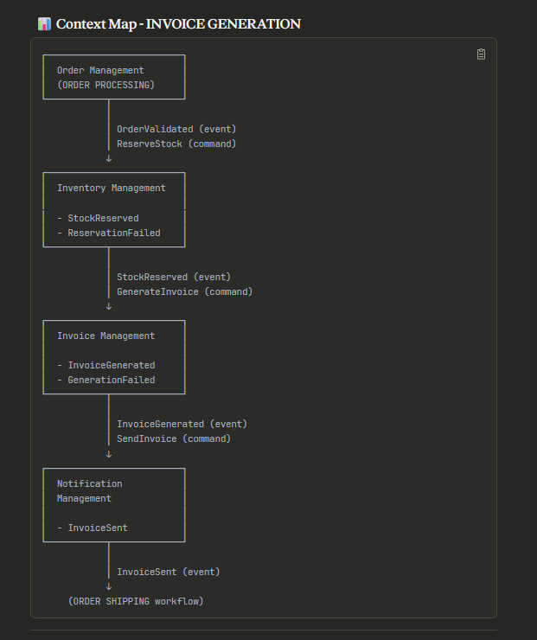

BOUNDED CONTEXTS pentru ORDER SHIPPING

Context 1: Fulfillment Management
Responsabilități:
- Coordonarea pregătirii comenzilor pentru expediere
- Gestionarea procesului de picking și packing
- Alocarea resurselor de depozit
Evenimente care aparțin contextului:
- OrderPrepared
- PreparationFailed
Comunicare cu alte contexte:
Evenimente publicate (shared events):
- OrderPrepared → trimis către Shipping Context
- PreparationFailed → trimis către Order Management Context (notificare)
Evenimente consumate din alte contexte:
- InvoiceSent (din Notification Management Context - INVOICE GENERATION workflow)
Comenzi primite:
- PrepareOrder (command declanșat de InvoiceSent event)

Context 2: Shipping Management
Responsabilități:
- Coordonarea cu curieri și servicii de livrare
- Gestionarea informațiilor AWB și tracking
- Managementul predării coletelor
Evenimente care aparțin contextului:
- OrderHandedOver
- HandOverFailed
Comunicare cu alte contexte:
Evenimente publicate (shared events):
- OrderHandedOver → trimis către Delivery Context și către sisteme externe de tracking
Evenimente consumate din alte contexte:
- OrderPrepared (din Fulfillment Management Context)
Comenzi primite:
- HandOverOrder (command declanșat de OrderPrepared event)

Context 3: Delivery Management
Responsabilități:
- Urmărirea procesului de livrare
- Gestionarea încercărilor de livrare (succese și eșecuri)
- Confirmarea livrărilor și închiderea comenzilor
Evenimente care aparțin contextului:
- OrderDelivered
- DeliveryFailed
Comunicare cu alte contexte:
Evenimente publicate (shared events):
- OrderDelivered → trimis către Order Management Context pentru finalizarea comenzii
- DeliveryFailed → poate declanșa HandOverOrder din nou (retry) sau escaladare
Evenimente consumate din alte contexte:
- OrderHandedOver (din Shipping Management Context)
Comenzi primite:
- DeliverOrder (command declanșat de OrderHandedOver event)
- RetryDelivery (în caz de DeliveryFailed)
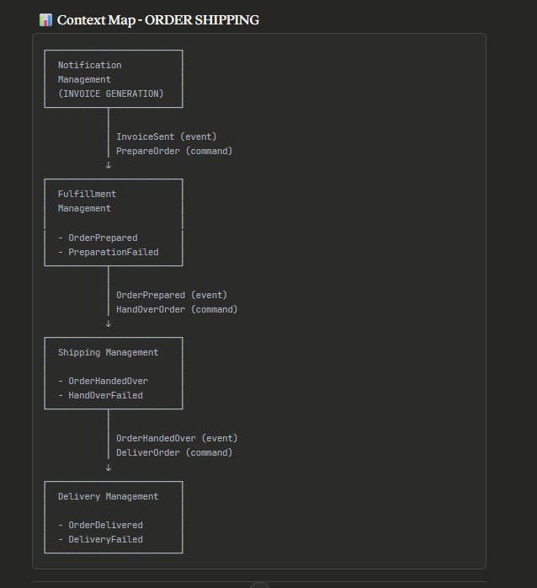

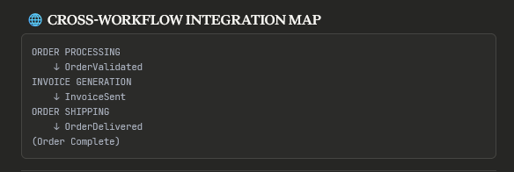

Flow complet prin toate workflow-urile:
ORDER PROCESSING:
- Customer → PlaceOrder → OrderPlaced
- System → CheckAvailability → AvailabilityChecked
- Operator → ValidateOrder → OrderValidated
INVOICE GENERATION: 4. System → ReserveStock → StockReserved 5. System → GenerateInvoice → InvoiceGenerated 6. System → SendInvoice → InvoiceSent
ORDER SHIPPING: 7. Operator → PrepareOrder → OrderPrepared 8. Operator → HandOverOrder → OrderHandedOver 9. Courier → DeliverOrder → OrderDelivered

1. BOUNDED CONTEXTS OVERVIEW

ORDER PROCESSING Workflow
Context | Aggregate | Commands | Events | Key Invariants
Order Management | Order | PlaceOrder, ValidateOrder | OrderPlaced, OrderValidated, OrderRejected | • Min 1 order line  • Total = sum of lines  • Valid status transitions
Inventory Management | Inventory | CheckAvailability | AvailabilityChecked, StockInsufficient | • Reserved ≤ Available  • Non-negative quantities

INVOICE GENERATION Workflow
Context | Aggregate | Commands | Events | Key Invariants
Inventory Management | StockReservation | ReserveStock | StockReserved, ReservationFailed | • Active not expired  • Min 1 item  • Max 24h expiry
Invoice Management | Invoice | GenerateInvoice | InvoiceGenerated, GenerationFailed | • Total = Subtotal + Tax  • Tax = Subtotal × Rate  • Sent invoices immutable
Notification Management | Notification | SendInvoice | InvoiceSent, SendingFailed | • Max 3 retries  • Sent has date  • Valid email format

ORDER SHIPPING Workflow
Context | Aggregate | Commands | Events | Key Invariants
Fulfillment Management | Fulfillment | PrepareOrder | OrderPrepared, PreparationFailed | • In-progress has operator  • Completed has package details  • Chronological timestamps
Shipping Management | Shipment | HandOverOrder | OrderHandedOver, HandOverFailed | • Handed over has courier info  • Valid status transitions  • AWB required
Delivery Management | Delivery | DeliverOrder | OrderDelivered, DeliveryFailed | • Max 3 attempts  • Delivered has recipient + proof  • Delivery window 8-20h

2. AGGREGATE STRUCTURES

Order (Order Management)
public class Order : AggregateRoot<OrderId>
{
// Properties: Id, CustomerId, Status, OrderLines, TotalAmount
// Factory
public static Result<Order> Place(customerId, orderLines, address, payment)
// Behaviors
public Result Validate(operatorId, finalTotal)
public Result Reject(reason, userId)
// Invariants: MIN_ORDER_AMOUNT, MAX_ORDER_LINES, Total consistency
}
Invoice (Invoice Management)
public class Invoice : AggregateRoot<InvoiceId>
{
// Properties: Id, Number, OrderId, Lines, Subtotal, TaxAmount, TotalAmount
// Factory
public static Result<Invoice> Generate(orderId, customerId, lines, taxRate)
// Behaviors
public Result MarkAsSent(sentAt)
// Invariants: Total = Subtotal + Tax, Sent immutable, Due date valid
}
Shipment (Shipping Management)
public class Shipment : AggregateRoot<ShipmentId>
{
// Properties: Id, OrderId, PackageId, CourierId, AWB, Status
// Factory
public static Result<Shipment> Create(orderId, packageId, address, weight)
// Behaviors
public Result HandOver(courierId, service, awb, cost)
public Result UpdateStatus(newStatus)
// Invariants: Valid status transitions, Handed over has courier details
}
Delivery (Delivery Management)
public class Delivery : AggregateRoot<DeliveryId>
{
// Properties: Id, ShipmentId, OrderId, Attempts, Status, RecipientName
// Factory
public static Result<Delivery> Create(shipmentId, orderId, courierId, address)
// Behaviors
public Result AttemptDelivery(notes)
public Result CompleteDelivery(recipient, signature, photo)
public Result FailDeliveryAttempt(reason, notes)
// Invariants: Max 3 attempts, Delivered has proof, Delivery window
}
```
---
## **3. COMMAND → EVENT MAPPING**
### **Complete Flow**
```
PlaceOrder → OrderPlaced
CheckAvailability → AvailabilityChecked
ValidateOrder → OrderValidated
ReserveStock → StockReserved
GenerateInvoice → InvoiceGenerated
SendInvoice → InvoiceSent
PrepareOrder → OrderPrepared
HandOverOrder → OrderHandedOver
DeliverOrder → OrderDelivered
```
---
## **4. VALIDATION RULES (FluentValidation)**
### **PlaceOrderCommandValidator**
- CustomerId: NotEmpty
- OrderLines: NotEmpty, Max 50 items
- Each line: ProductId NotEmpty, Quantity > 0, UnitPrice > 0
- DeliveryAddress: Valid format (Street, City, PostalCode, Country)
- PaymentMethod: NotNull
### **GenerateInvoiceCommandValidator**
- OrderId, CustomerId: NotEmpty
- InvoiceLines: NotEmpty
- Each line: Quantity > 0, UnitPrice > 0, Description MaxLength(500)
- TaxRate: Between 0 and 1
### **DeliverOrderCommandValidator**
- DeliveryId: NotEmpty
- RecipientName: NotEmpty, MaxLength(200)
- Signature OR ConfirmationPhoto: At least one required
- Notes: MaxLength(1000)
---
## **5. KEY INVARIANTS BY AGGREGATE**
### **Order**
1. Must have ≥ 1 order line
2. TotalAmount = Σ(OrderLine.TotalPrice)
3. Status transitions: Placed → AvailabilityChecked → Validated
4. Validated orders must have ValidatedBy + ValidatedAt
### **Invoice**
1. Total = Subtotal + TaxAmount
2. TaxAmount = Subtotal × TaxRate
3. Subtotal = Σ(InvoiceLine.TotalPrice)
4. Sent/Paid invoices are immutable
5. DueDate > GeneratedAt
### **Shipment**
1. HandedOver shipments must have: CourierId, AWB, HandedOverAt
2. Valid status transitions only (AwaitingHandover → HandedOver → InTransit → OutForDelivery → Delivered)
3. Terminal states (Delivered, Cancelled, Returned) cannot transition
### **Delivery**
1. Max 3 delivery attempts
2. Delivered status requires: RecipientName, DeliveredAt, (Signature OR Photo)
3. Delivery window: 08:00-20:00
4. Failed delivery only after 3 attempts
---
## **6. CROSS-CONTEXT INTEGRATION**
```
ORDER PROCESSING
OrderValidated (published)
↓
INVOICE GENERATION
ReserveStock (command)
↓
StockReserved (published)
↓
InvoiceSent (published)
↓
ORDER SHIPPING
PrepareOrder (command)
↓
OrderHandedOver (published)
↓
OrderDelivered (published)

7. VALUE OBJECTS
// Key Value Objects
Money { Amount, Currency }
Address { Street, City, PostalCode, Country }
Weight { Value, Unit }
Dimensions { Length, Width, Height }
AWB { Value, CourierCode }
OrderLine { ProductId, Quantity, UnitPrice, TotalPrice }

Total: 9 Bounded Contexts | 7 Aggregates | 9 Commands | 14 Events

